3D printing of pea protein

Materials and suppliers
- Pea Protein (https://buxtrade.de/en/products/pea-protein?_pos=1&_psq=pea&_ss=e&_v=1.0&variant=47942045925650 )
- Glycerol (https://www.emmelev.dk/glycerin )
- Xanthan gum (https://buxtrade.de/en/products/xanthan-gum?_pos=1&_psq=xanth&_ss=e&_v=1.0 )
- Hemp Dust (https://www.hanffaser-shop.de/shop/hanf---trockenstreu/ )
- Tap Water (https://www.harveywatersofteners.co.uk/wp-content/uploads/2024/08/tap-with-water.png ) :P

Machines used
- Dissolver: https://img.directindustry.com/images_di/photo-mg/35796-19924124.jpg It is something like that but we have to ask the people at CITA for the exact model.
- 3D printer : 3D printing was conducted with an in-house-built extrusion 3D printer prototype based on a robotic arm (ABB, IRB 1600 M2004) and an extrusion 3D printing head (3D printed in-house). The system utilised air pressure and a rotating screw to guide the material from the reservoir to the nozzle. During 3D printing, a moving speed of 40 mm/s, a nozzle diameter of 9 mm and a layer height of 4 mm were used.
**I have to note that I am not sure they are still using this set-up
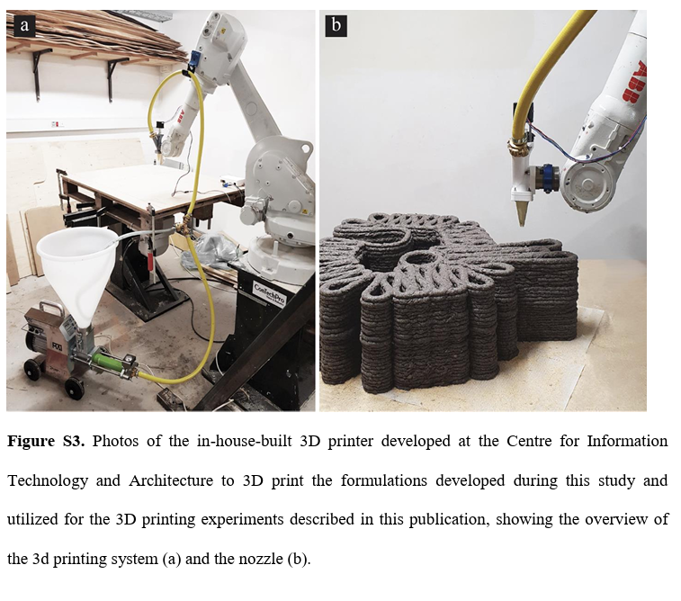
- All fillers needed to be milled at 0.25mm. That was done using the cutting mill SM2000. To mill 5kg it was needed around 5 hours. https://www.retsch.com/products/milling/cutting-mills/sm-200/

Fillers
No | Filler | Source | Source
1 | Bark Initial | DK | Convert A/S
2 | Pinje Bark | DK | Silvan (?)
3 | Pær Bark | DK | Silvan (?)
4 | Pynte Bark | DK | Silvan (?)
5 | Cotton(Blue Jeans) | DK | Convert A/S
6 | Cellulose Paper | DK | ?
7 | Wood Flour | DK | Hedensted Gruppen
8 | Hemp Dust | GE | hanffaser
9 | Seagrass | DK | Collected from Amager Beach
10 | Cotton | IN | Collected from farmers in India
11 | Sugarcane | IN | Collected from farmers in India
12 | Wheat Straw | IN | Collected from farmers in India
13 | Coffee Waste | DK | From coffee machines in DTU
14 | Castor | IN | Collected from farmers in India

Processing
Step 1: Add tap water with glycerol and mix well until it looks homogenous. (hand mixing)
Step 2: Add the Xanthan gum and mix with the hand blender. Xanthan gum is hard to dissolve and it will increase the viscosity of the mixture. (hand blender for 5min)
Step 3: Add the pea protein and homogenize using the dissolver (5-10min)
Step 4: Add slowly the fillers by mixing with the dissolver first. When the mixture increases a lot in viscosity use the hand blender. When it’s no longer possible to mix with the blender use your hands and treat it like a dough. The whole process can take up to 15-20min.
Store with the lid to avoid water evaporation.
If printed the next day it has to be stored in the fridge (0-5ºC).
Print.
Dry the print in the oven at 150ºC for 45min.

Recipe
Ingredient | Recipe 1 (%) | Suggested recipe trial (%) **
Pea Protein | 11,8 | 26,9
Glycerol | 3 | 13,5
Water | 65,2 | 53,9
Xanthan Gum | 0,1 | 0,3
Hemp Dust | 19,9 | 5,4

**The recipe optimization focuses on reduction of water as it is what causes the problems during drying (delamination and shrinkage). By reducing the water content, viscosity increases. Due to processing limitations, there is an upper limit in viscosity. Therefore, the filler content needs to be reduced as well.

Notes from Elefteria email (received on 2-June, title: “Re: RAW meeting – mapping out the pea protein production process):
On why the percentage of hemp dust is so low in suggested recipe trial:
- We noticed we had some problems with the drying as I mentioned in our meeting. To reduce the cracking during drying we needed to reduce the water. If we reduced the water the viscosity was going to increase dramatically. After evaluating the pros and cons with the people at CITA and the things we needed to sacrifice to have a printable recipe with the hemp dust we concluded to the suggested trial. CITA told us that they dont mind dropping a lot in filler content and if the suggested trial worked we were gonna try load as much as we could. We think we overshooted the filler content in the initial trials. With some fillers it worked but with hemp it didnt. It is about trial and error.

On whether each filler would have the same percentage as hemp dust:
- I think I just answered that. Each filler has a different effect in viscosity based on the filler aspect ratio (how fibrous or spherical is) but also based on their density. For example, if we need 10g of filler we were going to add a lot more of cotton than wood flour (based on volume) even if the weight was the same. So in case we try other fillers the recipe will need to be optimised all over again. We are working on doing this in a bit more automated way with the filler characterization that was initiated a few months ago.

Additional adjustments include glycerol increase. Glycerol offers the final plasticization of the print. We noticed that the current ratio between protein and glycerol results in a brittle result. Depending on the requirements from CITA, glycerol is another factor that can vary in the final recipe. The pictures below shows the effect of increase of glycerol (from left to right).
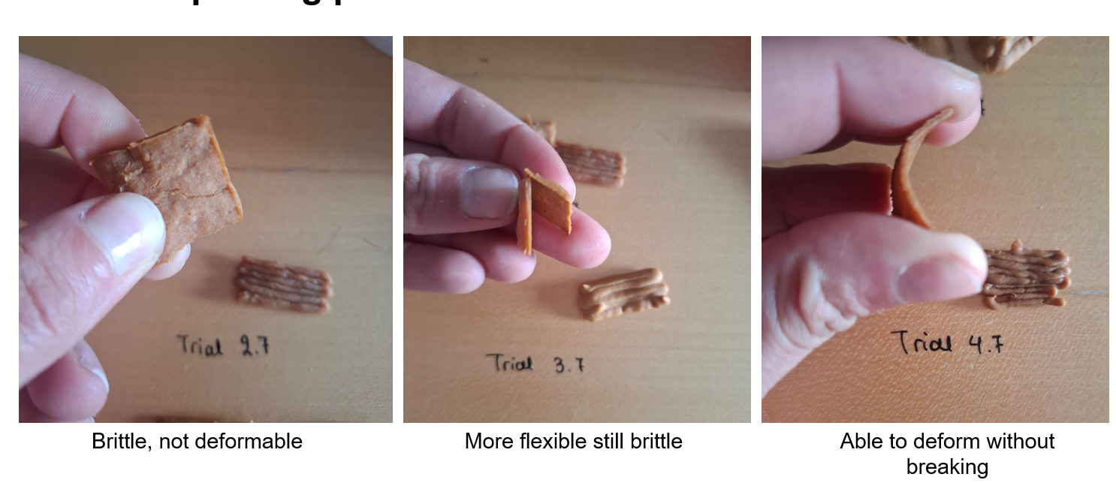

Xanthan gum improves interlayer adhesion. How each printed layer sticks to the previous one but also the integrity of the print. A previous study explored that with pea protein. So far we are not varying the XG content. It also affects the viscosity as it was mentioned before.
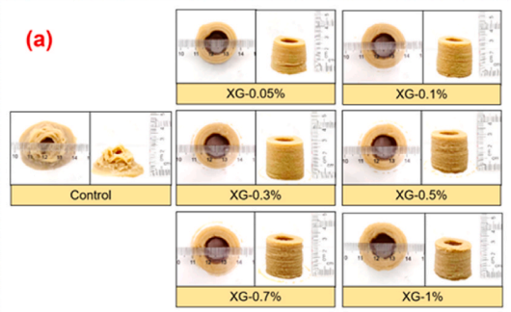

Protein Extraction
Check the AEIEP method:
The AEIEP method (Alkaline Extraction-Isoelectric Precipitation) is the standard industrial wet fractionation process used to extract and isolate plant proteins (such as pea, soy, and oat).
It uses water baths extracting the protein by altering the ph and using centrifuge. No chemicals or harmful solvents.
Methods include milling, centrifuge, drying

